**Chapter - 3**

**Even and Odd function**

A function  is called even if for all *x* in its domain. The graph of an even function is symmetric with respect to the *y*-axis. For example, any constant function, are even functions.

A function  is called odd if for all *x* in its domain. The graph of an odd function is symmetric with respect to the origin. For example, are odd functions.

Most functions, however, are neither even nor odd.

**Arithmetic Combinations of Even and Odd Functions**

|  |  |  |  |
| --- | --- | --- | --- |
| Operations | Even and Even | Odd and Odd | Even and Odd |
| +/- | Even | Odd | Neither |
| ×/÷ | Even | Even | Odd |

**Calculus Properties of Even and Odd Functions**

Suppose the function  is an even function, continuous on, then



Suppose the function  is an odd function, continuous on, then



**Exercise 3.1**

**1.** Determine the period of the following functions.

(a) , (b) (c) (d) ,

(e)

(a) Ans: (b) Ans: (c) Ans: (d) Ans: (e) Ans:

**2.** Determine whether the following functions are even, odd or neither.

1. (b) (c) (d)

(e) (f) (g) (h).

**Periodic Function:**

Let A function  is said to be a periodic function if.

where is called period of *f*.

**Example 01:**

Describe the function shown in figure 1 with period 2 in two different ways:

1. By considering its values on the interval 

2. By considering its values on the interval 



Figure 1: A function of period 2

**Solution:**

1. On the interval, the function is a portion of the line  thus  if . The relation describes *f(x)* for all other values of *x*.

2. On the interval, the function consists of two lines. So we have



The relation describes *f* for all other values of *x*.

Example: 



So,  is periodic function and period.

**Extension to an odd and even periodic function:**

Let*y=f (x)* is function defined on *0 ≤ x ≤ L*.

The odd extensions of *f(x)* are, 

fourier8.tif

Figure 2: Graph of function *f(x)* and its odd extension

Similarly, the odd extension of any piecewise function is as follows:

fourier9.tif

Figure 3: Graph of piecewise function *f(x)* and its odd extension

The even extensions of *f(x)* are, 

**fourier11.tif**

Figure 4: Graph of function *f(x)* and its even extension

Similarly, the even extension of any piecewise function is as follows:

**fourier12.tif**

Figure 5: Graph of piecewise function *f(x)* and its even extension

**Example 02:** Sketch the even extension of the function 

**Solution:**

The even extension of the function is,



The sketch of the function and the even extension is,

fourier13.tif

Figure 6: Graph of function *g(x)* and its even extension

**Example 03:** Sketch the odd extension of the function 

**Solution:**

The odd extension of the function is,



The sketch of the function and the odd extension are,

fourier14.tif

Figure 7: Graph of piecewise function *g(x)* and its odd extension

**Some useful formulas:**

|  |
| --- |
|  |
| If is an odd number then  and |

**Useful technique for integration by parts:**

|  |  |  |
| --- | --- | --- |
| sign | Differentiation | Integration |
| + |  |  |
| - |  |  |
| + |  |  |
| - | 0 |  |





=  = .

**Full range Fourier series in Real form**

The Fourier series is named in honor of [Jean-Baptiste Joseph Fourier](https://en.wikipedia.org/wiki/Jean-Baptiste_Joseph_Fourier) (1768–1830), who made important contributions to the study of [trigonometric series](https://en.wikipedia.org/wiki/Trigonometric_series). Fourier introduced the series for the purpose of solving the [heat equation](https://en.wikipedia.org/wiki/Heat_equation) in a metal plate. In [mathematics](https://en.wikipedia.org/wiki/Mathematics), it decomposes any [periodic function](https://en.wikipedia.org/wiki/Periodic_function) or periodic signal into the weighted sum of a (possibly infinite) set of simple oscillating functions, namely [sines/cosines](https://en.wikipedia.org/wiki/Sine_wave) and both (or, equivalently, [complex exponentials](https://en.wikipedia.org/wiki/Complex_exponential)). The fields of electronics, quantum mechanics, and electrodynamics all make heavy use of the Fourier series. Additionally, other methods based on the Fourier series, such as the FFT (Fast Fourier Transform – a form of a Discrete Fourier Transform [DFT]), are particularly useful for the fields of Digital Signal Processing (DSP).

Suppose *f* (*x*)is a periodic function with a period *T* = 2*L* or is defined on the interval (where *L* could be the length of a violin string or the length of a rod in heat conduction and so on). Then the *Fourier series* representation of *f* (*x*)is a trigonometric series (that is, it is an infiniteseries consists of sine and cosine terms) of the form,



where





and



The coefficients are called the Fourier coefficients of *f* (*x*).

Note that the cosine functions are even, while the sine functions are odd.

If *f* (*x*) is an even function then the integrand in (4) is odd, so for all *n*, leaving a ***Fourier cosine series (and perhaps a constant term) only for f (x)***.

If *f* (*x*) is an odd function then the integrand in (2) and (3) are odd, so  for all *n*, leaving a ***Fourier sine series only for f (x).***

**Example 04:**

Find a Fourier series for *f* (*x*) = *x*, −2 < *x* < 2, *f* (*x* + 4) = *f* (*x*).

**Solution:**

Untitled.tif

Figure 8: Graph of periodic function *f(x)*

Here, hence 





|  |  |  |
| --- | --- | --- |
| sign | D | I |
| + |  |  |
| - |  |  |
| + |  |  |

Again,











Now, we know the Fourier series of  in the interval  is



Therefore, the Fourier series for *f (x)* is





Figure 9: The graph of the partial sum of the first 30 terms of the above Fourier series

**Example 05:** Compute the first 4 components of the trigonometric Fourier series for the wave form below

fourier24.tif

.

**Solution:** From the figure we can construct the function as



Here, hence 





|  |  |  |
| --- | --- | --- |
| Sign | D | I |
| + |  |  |
| - | -1 |  |
| + |  |  |



|  |  |  |
| --- | --- | --- |
| sign | D | I |
| + |  |  |
| - | -1 |  |
| + |  |  |



Therefore the Fourier series for *f (x)* is



Now, the first few partial sums in the Fourier series are







 and so on.

The graphs of successive partial sums approach *f (x)* more closely.

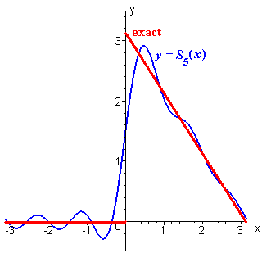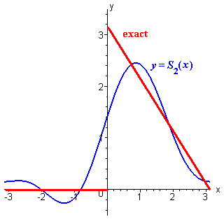

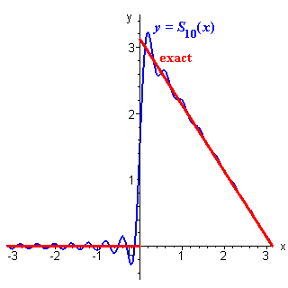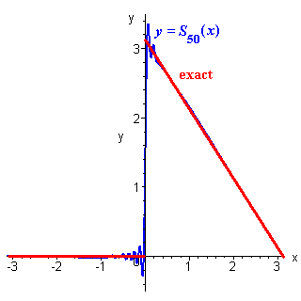

Figure 9: The graph of the partial sum of the first 50 terms of the above Fourier series

**Example 06:** Find the Fourier series expansion for the standard square wave,



**Solution:**

**fourier15.tif**

Figure 10: The graph of function *f(x)*

Here, hence 









Therefore the Fourier series of *f(x)* is



The graphs of the third and ninth partial sums (containing two and five non-zero terms respectively) are displayed here, together with the exact form for *f* (*x*), with a **periodic extension** beyond the interval (–1, +1) that is appropriate for the square wave.

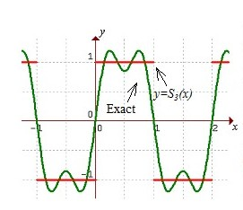 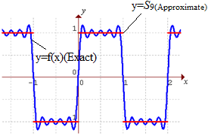

Figure 11: The graph of the partial sum of the first 9 terms of the above Fourier series

**Example 07:** Find the Fourier series for the function *f* (*x*) defined by

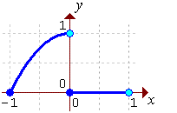f(x) = (1 - x^2) on -1 < x < 0;  0 else

**Solution:**

Here, hence 

Integral for a_0

Figure 12: Graph of *f(x)*

|  |  |  |  |  |  |  |  |  |  |  |  |  |  |  |  |  |  |  |  |  |  |  |  |  |  |  |  |  |  |  |
| --- | --- | --- | --- | --- | --- | --- | --- | --- | --- | --- | --- | --- | --- | --- | --- | --- | --- | --- | --- | --- | --- | --- | --- | --- | --- | --- | --- | --- | --- | --- |
| a0 = 2/3   |  |  |  | | --- | --- | --- | | Sign | D | I | | + |  |  | | - |  |  | | + |  |  | | - | 0 |  |   Integral for a_n  Integral for a_n  a_n = -2(-1)^n / (n pi)^2   |  |  |  | | --- | --- | --- | | Sign | D | I | | + |  |  | | - |  |  | | + |  |  | | - | 0 |  |   Integral for b_n  Integral for b_n  b_n = 2((-1)^n - 1) / (n pi)^3 - 1/(n pi)  The Fourier series of   *f* (*x*)   on [–*L*, +*L*] in general is  Therefore    The first few terms of this series are 1/3 + 2 cos(pi x)/pi^2 - (4/pi^3 + 1/pi) sin(pi x)     - cos(2 pi x)/(2 pi^2) - sin(2 pi x)/(2 pi) + ...  Untitled7.png |

Figure 13: The graph of the partial sum of the first 4 terms of the above Fourier series

**Example 08:** Find the Fourier series for the function *f* (*x*) defined on the interval [–1, 1] by

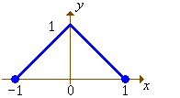f(x) = 1 - |x|

**Solution:**

Figure 14: The Graph of *f(x)*

|  |  |  |
| --- | --- | --- |
|  | Here,hence  Integral for a_0 a0 = 1 | |
| Integral for a_n Integral for a_n Integral for a_n a_n = 4 / (n pi)^2  for odd  n  only | | |  |  |  | | --- | --- | --- | | Sign | D | I | | + |  |  | | - |  |  | | + |  |  | | |

  
Therefore the Fourier series is



The first few terms of this series are

1/2 + (4/pi^2) ( 
     cos(pi x) + cos(3 pi x)/9 + cos(5 pi x)/25 + ...)

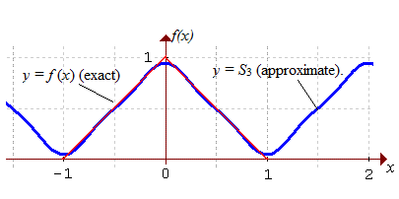

Figure 15:The graph of *f(x)* and the third partial sum*S3*

**Full range Fourier series in Complex form**

Consider, be defined in the interval,]. Fourier series of the function, in real form:



If be the periodic function of period 2L in the interval,, Fourier series of the function, in complex form can be written in the following form:

.

Here 

The coefficient,is called complex Fourier coefficient. The complex form of Fourier series is algebraically simpler and more symmetric. Therefore, it is often used in physics and other sciences.

**Example 09:** Find the complex form of Fourier series of function, in the region, .

Solution:

The Fourier series of function in complex form in the interval [c-L,c+L] is given by

.







Eq. (1) becomes,



This is the required complex form of Fourier series.

**Exercise 3.2**

1. Sketch the graph and find the Fourier coefficients and then Fourier series of the function of  in the interval 

Ans: , , 

1. Sketch the graph and find the Fourier coefficients and then Fourier series of the function of  in the interval 

Ans: , , 

1. Sketch the graph and obtain the Fourier series of the function.

Ans: , , .

1. Sketch the graph and obtain the Fourier series of the function  in the interval

Ans: , , .

1. Find the complex form of Fourier series of the following function:
2. in the region, .
3. in the region, .
4. in the region, -

**Half-Range Fourier series**

If *f(x)* and *f* ′*(x)* are piecewise continuous functions defined on the interval *0 ≤ x ≤ L*, then *f(x)* can be extended into an even periodic function, *F*, of period 2*L*, such that *f* (*x*) = *F*(*x*) on the interval [0, *L*], and whose Fourier series is, therefore, a cosine series.

Similarly, *f(x)* can be extended into an odd periodic function of period 2*L*, such that

*f* (*x*) = *F*(*x*) on the interval (0, *L*), and whose Fourier series is, therefore, a sine series.

The process that such extensions are obtained is often called cosine /sine series *half-range expansions*.

A Fourier series for *f* (*x*), valid on [0, *L*], may be constructed by extension of the domain to [–*L*, *L*].

An odd extension of *f(x)* of the period *2L* leads to a **Fourier sine series**:

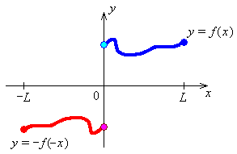

Figure 01: Odd extension of *f(x)*



where





An even extension of *f(x)* of period *2L* leads to a **Fourier cosine series**:

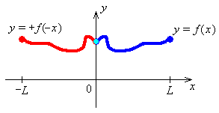

Figure 02: Even extension of *f(x)*



where,  and 

**Example 01:** Find the Half range Fourier sine and cosine series for



**Solution:**

**Half range Fourier sine series (Odd periodic extension)**

Fourier36.tif

|  |  |  |
| --- | --- | --- |
| Sign | D | I |
| + |  |  |
| - |  |  |
| + |  |  |

Figure 03: Odd extension of *f(x)*

Here, hence   
An odd extension of *f* (*x*) is required to the interval [–1, 1].  
*an* = 0   for all *n*.







|  |  |  |
| --- | --- | --- |
| Sign | D | I |
| + |  |  |
| - |  |  |
| + |  |  |



Therefore the half range Fourier sine series for *f* (*x*) on [0, 1] (which is also the Fourier series for *f* (*x*) = *x* on

[–1, 1]) is



**Half range Fourier cosine series (Even periodic extension)**

**Fourier35.tif**

|  |  |  |
| --- | --- | --- |
| Sign | D | I |
| + |  |  |
| - |  |  |
| + |  |  |

Figure 04: Even extension of *f(x)*

Here, hence   
An even extension of *f* (*x*) is required to the interval [–1, 1].  
*bn* = 0   for all *n*.



|  |  |  |
| --- | --- | --- |
| Sign | D | I |
| + |  |  |
| - |  |  |
| + |  |  |









Therefore the half range Fourier cosine series for *f* (*x*) on [0, 1] (which is also the Fourier series for *f* (*x*) = *x* on [–1, 1]) is



**Example 02:** Find the first few terms of half range Fourier sine and cosine series for the wave form below

Fourier37.tif

**Solution:**

From the figure we can construct the function as

****

**Half range Fourier sine series (Odd periodic extension)**

Fourier39.tif

Figure 05: Odd extension of *f(x)*

Here, hence

An odd extension of *f* (*x*) is required to the interval [–1, 1].  
*an* = 0   for all *n*.

|  |  |  |
| --- | --- | --- |
| Sign | D | I |
| + |  |  |
| - |  |  |
| + |  |  |







Therefore the Fourier sine series for *f* (*x*) = *x* on [0, 1] (which is also the Fourier series for *f* (*x*) = *x* on [–1, 1]) is



Or



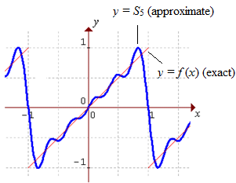

Figure 06: The graph of *y=f(x)* and the partial sum of the first 5 terms of the above Fourier series

**Half range Fourier cosine series (Even periodic extension)**

Fourier38.tif

Figure 07: Even extension of *f(x)*

Here, hence

The even extension of *f* (*x*) is required to the interval [–1, 1].

*bn* = 0   for all *n*.

Evaluating the Fourier cosine coefficients, 

|  |  |  |
| --- | --- | --- |
| *Sign* | *D* | *I* |
| *+* |  |  |
| *-* |  |  |
| *+* |  |  |

and 

 

Evaluating the first few terms,



or 

Therefore the Fourier cosine series for *f* (*x*) = *x* on [0, 1] (which is also the Fourier series for *f* (*x*) on [–1, 1] ) is



or



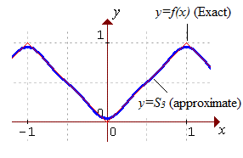

Figure 08: The graph of *y=f(x)* and the partial sum of the first 3 terms of the above Fourier series.

**Example 03:** Find the half range Fourier cosine series for the function   *f* (*x*)   defined on the interval [0, 2] by

f(x) = 4 - x^2

**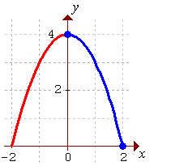Solution:**

|  |  |
| --- | --- |
|  | Here,hence Figure 09: Even Extension of *f(x)* An even extension of *f* (*x*) is required *bn* = 0   for all *n*. Integral for a_0  a0 = 16/3 |

|  |  |  |  |  |  |  |  |  |  |  |  |  |  |  |  |  |
| --- | --- | --- | --- | --- | --- | --- | --- | --- | --- | --- | --- | --- | --- | --- | --- | --- |
| |  |  |  | | --- | --- | --- | | Sign | D | I | | + |  |  | | - |  |  | | + |  |  | | - | 0 |  |   Integral for a_n Integral for a_n a_n = 16(-1)^(n+1) / (n pi)^2  Therefore the Fourier series is  f(x) = 8/3 + (16/pi^2) Sum { (-1)^(n+1) cos(n pi x/2)/(n pi)^2 } |  |

The first few terms of this series are

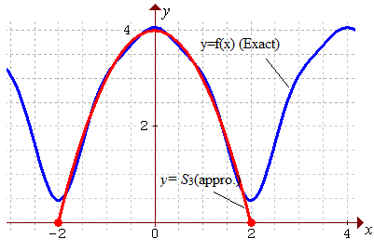  
Figure 10: The graph of *y=f(x)* and the partial sum of the first 3 terms of the above Fourier series

**Example 04:** Find the half range Fourier sine series for the function   *f* (*x*)   defined on the interval [0, 2] by

f(x) = 2x - x^2

**Solution:**

Here, henceAn odd extension of *f* (*x*) is required.  
*an* = 0   for all *n*.

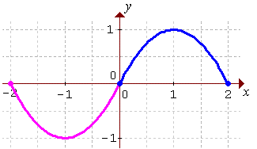Integral for b_n

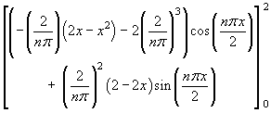

Figure 11: Odd extension of *f(x)*

|  |  |  |
| --- | --- | --- |
| Sign | D | I |
| + |  |  |
| - |  |  |
| + |  |  |
| - | 0 |  |

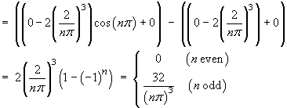

Therefore the Fourier series is

f(x) = (32/pi^3) Sum { sin((2k-1) pi x/2)/(2k-1)^3 }

The first few terms of this series are

8/3 + (16/pi^2) ( 
     sin(pi x/2) + sin(3 pi x/2)/27 + sin(5 pi x/2)/125 + ...)

The partial sum of just the first *three* non-zero terms yields an excellent approximation everywhere. The graph of *y=f(x)* and the third partial sum *y=S3* illustrates:

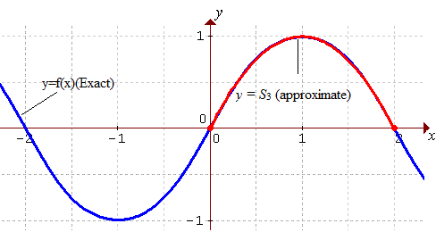  
Figure 12: The graph of *f(x)* and the partial sum of the first 3 terms of the above Fourier series

**Exercise: 3.3**

1. Sketch the odd and even extension and express as a half range Fourier sine and cosine series in the interval



1. Sketch the odd and even extension and express as a half range Fourier sine and cosine series in the interval

1. Sketch the odd and even extension and find the half range Fourier sine and cosine series of

Ans: and

1. Sketch the odd and even extension and find the half range Fourier sine and cosine series of

Ans:

1. Sketch and find the half range Fourier sine and cosine series of in the interval

Ans:

and

**Fourier Integral**

Fourier integral is a formula for the decomposition of a non-periodic function into harmonic components whose frequencies range over a continuous set of values.

Let *f* (*x*)is a periodic function with a period *T* = 2*L* or is defined on the interval Then the *Fourier series* representation of *f* (*x*)is a trigonometric series (that is, it is an infiniteseries consists of sine and cosine terms) of the form,







Note that, 



As, 





.

Hence, the Fourier integral of non-periodic function *f(x)* but piecewise continuous in any infinite interval as follows:



Where,  and 

**Fourier cosine integral:**



 and 

If the function *f(x)* is even then and writing,

 (Even) and (odd)

Hence, the **Fourier cosine integral** of *f(x)* is



**Fourier sine integral:**



 and 

If the function *f(x)* is odd and writing then,

(odd) and(Even)

Hence, the **Fourier sine integral** of *f(x)* is



|  |
| --- |
| Note that: |

**Example: 01**

Find the Fourier integral of where and hence prove that 

**Solution:**

Here 



 



Hence the Fourier integral of *f(x)* is,





Now,

 (Proved)

**Example: 02** Find the Fourier integral of the function



**Solution:**









Hence the Fourier integral of *f(x)* is,





**Example: 03** Find the Fourier integral of the function



**Solution:** The Fourier integral of *f(x)* is,



where,





and





Hence the Fourier integral of *f(x)* is,





**Example: 04**

Find the Fourier **sine integral** of the function

.

**Solution:**

We know, for Fourier sine integral 



Hence the Fourier sine integral of *f(x)* is,



**Exercise: 3.4**

1. Find the Fourier integral of the function

Ans:

1. Find the Fourier sine and cosine integral of the function

.

1. Find the Fourier integral of the function

Ans:

1. Find the Fourier integral of when  for

and hence prove that .

1. Find the Fourier integral of when  for

and hence prove that .

**Fourier Transform**

The Fourier Transform is a generalization of the Fourier Series. Strictly speaking it only applies to continuous and aperiodic functions. The Fourier Transform converts a set of time domain data vectors into a set of frequency domain vectors. The Fourier transform is called the frequency domain representation of the original signal. The term Fourier transforms refers to both the frequency domain representation and the mathematical operation that associates the frequency domain representation to a function of time.

**Finite Fourier sine transforms:**

From half range Fourier sine series of  in the interval 



Where  and  is called finite Fourier sine transform.

From equation (1) ,we get

 is called inverse finite Fourier sine transform of .

**Finite Fourier cosine transforms:**

From half range Fourier cosine series of  in the interval 



Where  and  and  is called finite Fourier cosine transform.

From equation (2), we get

 is called inverse finite Fourier cosine transform of 

**Infinite Fourier sine transforms:**

For an **odd** function, the Fourier integral is the Fourier sine integral

 where

We now set Then from (4) writing  we have



This is called **infinite Fourier sine transform** of . Similarly, from (3) we have,



This is called the **inverse infinite Fourier sine transform** of .

**Infinite Fourier cosine transforms:**

For an **even** function, the Fourier integral is the Fourier cosine integral

 where

We now set Then from (4) writing we have



This is called **infinite Fourier cosine transform** of . Similarly, from (5) we have,



This is called the **inverse infinite Fourier cosine transform** of .

**Example: 01**

Find the Fourier sine transform of.

Solution: Here 

We know the finite Fourier sine transforms of  is

  









 (Ans.)

**Example: 02** Find the Fourier cosine transform of.

Solution: Here 

We know the finite Fourier cosine transforms of  is





 



**Example 03:** Find the Fourier sine and cosine transform of 

**Solution:** We know the **infinite Fourier sine transform** is,









We know the **infinite Fourier cosine transform** is,









**Exercise: 3.5**

Sketch the graph and then find the (a) finite Fourier sine transform, and (b) finite Fourier cosine transform of the following functions:

1.  where

Ans:

1.  .

Ans: ,

1. Sketch the graph and then find the (a) infinite Fourier sine transform, and (b) infinite Fourier cosine transform of  .

Ans: 

1. Sketch the graph and then find the (a) infinite Fourier sine transform, and (b) infinite Fourier cosine transform of  .

Ans:

1. Sketch the graph and then find the (a) infinite Fourier sine transform, and (b) infinite Fourier cosine transform of

Ans: , .

**Reference:**

W.H. Press et.al., Numerical Recipes in Fortran 90, Cambridge University Press 1996.

* Advance Engineering Mathematics, 10th edition by Erwin Kreyszig, Herbert Kreyszig, Edward J. Normintion.